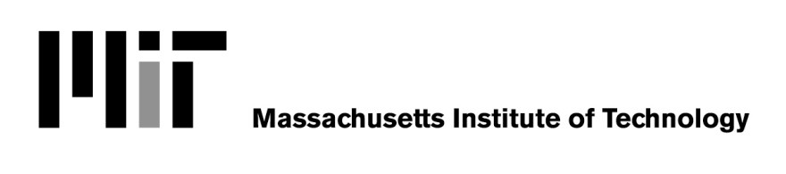

Withdrawal of Consent to Electronic W-2

SECTION I: Employee/Student Information

Last Name First Name

MIT ID# MIT Phone

SECTION II: Electronic W-2 Service
Use this form only if you have consented to electronic-only delivery of your W-2, but you have changed your mind and now want MIT to send you your W-2 via U.S. mail. If you have not already consented to electronic-only delivery, you do
not need to submit this form to continue receiving your W-2 from MIT via U.S. mail. This form is only used for withdrawing
consent that you have previously given.
Please read the Electronic Form W-2 Disclosure Notice for more information.
Withdrawal of consent will be effective on the date received by HR/Payroll (campus) or the Workforce Service Center
(Lincoln) and will be confirmed in writing or by email. If consent is withdrawn, it will only be effective for W-2s not yet issued.

MIT provides 24-hour on-line access to your current and previous (back to 2009) W-2s through Atlas. If you wish to change back to electronic-only delivery after you have submitted this form, please go to Atlas, search eW-2s, and click "Go Paperless" on the W-2 Forms screen.

Please contact HR/Payroll if you have any questions -- payroll@mit.edu, 617-253-4255.

Reason (Optional):
It would be helpful for MIT HR/Payroll to understand why you wish to receive a paper W-2 from MIT via U.S. mail. If you wish, please tell us your reason in the space below:

I would like to withdraw my consent to electronic-only delivery of my W-2 form, and request that MIT mail a printed W-2 form to my address on file with MIT HR/Payroll.

Employee’s Signature Date

Please return the completed form to:

Campus Employees/Students: Lincoln Laboratory Employees:

MIT
77 Massachusetts Ave.
HR/Payroll, NE49-3131
Cambridge, MA 02139-4307
MIT Lincoln Laboratory
244 Wood St.
Workforce Service Center, S2-112
Lexington, MA 02421-6426

01/09/2014

